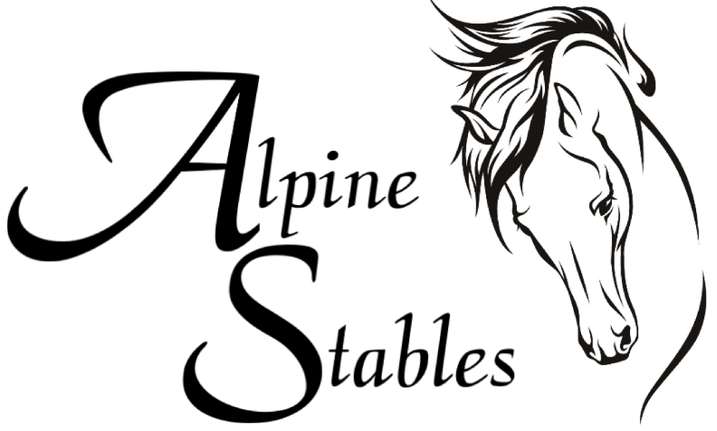

3700 Holland Ave. Cobble Hill, |BC, Canada V0R 1L3 |riding@alpinestable.com

Checklist of what to bring

1____BOOTS WITH A HEEL

2____SUNSCREEN

3____BATHING SUIT, HAT, TOWEL

4____PANTS, EXTRA CLOTHING

5____MEDICATIONS

6____SLEEPING BAG, PILLOW
7____TENT

8____FLASHLIGHT

8____TOILETRIES

10___WATER BOTTLE WITH NAME

11___ANY OTHER SPECIAL NIGHT TIME GOODIES

WE AT ALPINE STABLES ARE NOT RESPONSIBLE FOR LOST OR
STOLEN ITEMS.

PLEASE LEAVE ANY VALUABLES AT HOME.

Lots of Horse Sense

At Alpine Stables we strive in teaching children as well as adult’s horse sense. We take great pride in sharing our knowledge while at the same time having safe educational fun. This is a unique opportunity to learn the care and responsibility of owning a horse.

